Exam 2021
Problem 1
A)
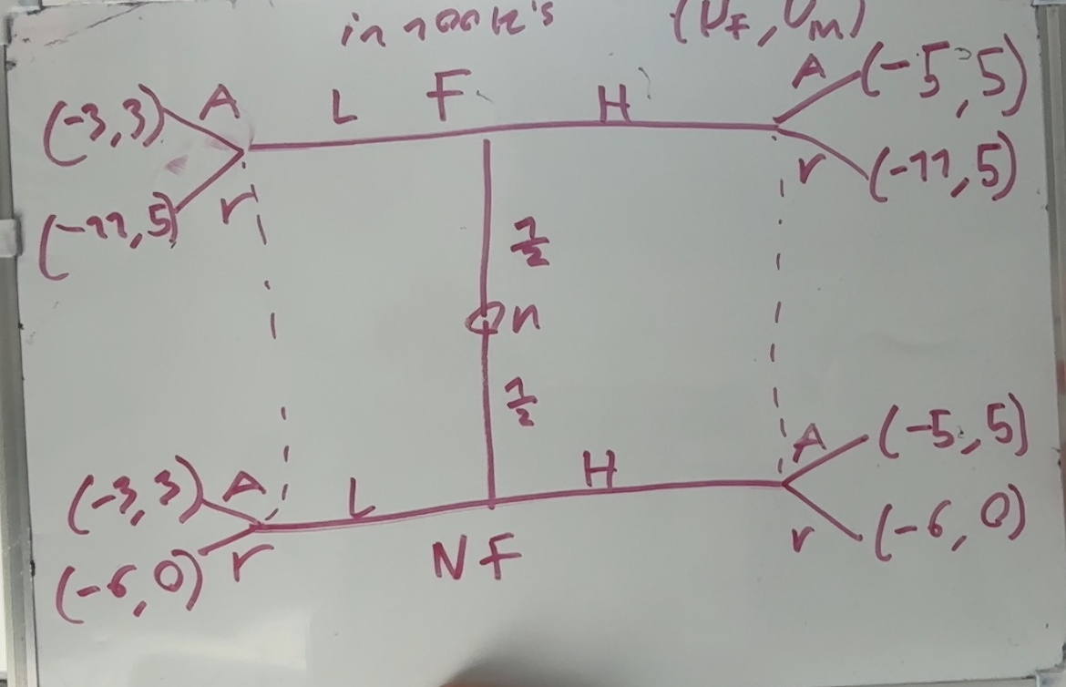
b)
We siply check all seperating and pooling EQ
$\left(H,L\right):$ Municipality accepts low offer and is indifferent between accepting and rejecting the high offer
Either way if firm when at fault deviates to Low offer the firm will gain higher utility making this not an EQ

$\left(L,H\right):$ M will reject low and accept high
F by playing H in the Fault state will get higher utility $-5>-11$ making this not an EQ

$\left(H,H\right):$ M will play A for H since $5>\frac{5}{2}=2.5$
For it to be an EQ M needs to play r for L otherwise F will deviate to only pay 3
Is an PBE

$\left(L,L\right):$M will play A in L since $3>\frac{5}{2}=2.5$
F will never deviate since it has its highest possible payoff in both paths
Is an PBE

c)
(H,H): both sender types have possible paths to higher utility meaning there is no meaningfull way to assign 0 conditional probability in any of the states

(L,L): both sender types get thir maximum utility meaning that there are never any resaon for any of them to deviate
In other words there are no sender typeswho can get higher utility by deviating period

Problem 2:

Constant marginal costs im dividing by 1000 just to make everything easier
$$MC=c=100⇒c\left(q_{i}\right)=c·q_{i}$$
Above im assuming 0 sunk cost in machinery vut in general this does not change the calculation apar from the total utility in the end

Linear price(inverse demand function )
$$P\left(q\right)=α-q$$
$$α=200$$
$$q=\sum_{i=1}^{n}{q_{i}}$$
This gives each firm the utility function
$$Π_{i}\left(q_{i},q_{-i}\right)=q_{i}·\left(α-q_{i}-\sum_{s≠i}{q_{s}}\right)-q_{i}·c$$
Each firm will maximise their own utility giving them their best responce functions
$$\frac{∂Π_{i}}{∂q_{i}}=α-2q_{i}-\sum_{s≠i}{q_{s}}-c=0⇔q_{i}=\frac{α-c-\sum_{s≠i}{q_{s}}}{2}=\frac{200-100-\sum_{s≠i}{q_{s}}}{2}$$

This type of EQ only happens if every player ”guesses right” and make their best responses
In this case this means
$$q_{s}=q_{i}∀s∈\left\{1,…,n\right\}$$
From where we can get the EQ
$$q_{i}=\frac{200-100-\left(n-1\right)·q_{i}}{2}=50-\frac{n-1}{2}·q_{i}$$
$$⇔q_{i}\left(1+\frac{n-1}{2}\right)=50⇔\frac{q_{i}\left(n+1\right)}{2}=50⇔q_{i}^{⋆}=\frac{100}{n+1}$$
Giving the prices
$$p^{⋆}=200-n·\frac{100}{n+1}$$
- This is exactly the case where n=1 since there is no competition the firms will act as 1
$$Π=\sum_{i=1}^{n}{Π_{i}}=q·\left(α-q\right)-q·c$$
$$q=\sum_{i=1}^{n}{q_{i}}$$
I will still show it
$$\max_{q}{q·\left(α-q\right)-q·c=Π}$$
$$\frac{∂Π}{∂q}=α-2q-c=0⇔q=\frac{α-c}{2}=\frac{200-100}{2}=50=q^{⋆}$$
With $p^{⋆}=200-50=150$
Giving each firm profit
$$π_{i}^{cartal}=\frac{50}{n}·150-100·\frac{50}{n}$$

- Still assuming 0 sunk costs of production
First i need the profit of playing the cournot EQ
$$π_{i}^{C}=\frac{100}{n+1}·\left(-n·\frac{100}{n+1}\right)$$

We consider the ”grim trigger” strategy if any player ever deviates we deviate forever

To evaluate this we need to find the profit of a ”1 step deviation”
But this is quite easy as a player i wil simply play their best response

$$q_{i}^{deviation}=50-\frac{\sum_{s≠i}{q_{s}}}{n+1}=50-\frac{\left(n-1\right)50}{n·2}$$
This deviation gives the price
$$p^{deviation}=200-\left(50-\frac{\left(n-1\right)50}{n·2}\right)-\frac{\left(n-1\right)50}{n}=200-100+\frac{\left(n-1\right)50}{n·2}+\frac{50}{n}$$
$$=100+\frac{n+1}{n·2}·50$$
Giving the deviant profit

I re read the assignment and realised i just need to come up with 1 counterexample

For $δ=0$ there are ”no consequences” meaning that the game is actually just a 1 off game in terms of utility. Thus every player must play their best responses in any EQ
We check if $\frac{50}{n}$ is a best respnse in the proposed EQ
$$q_{i}^{⋆}=\frac{200-100-\sum_{s≠i}{q_{s}}}{2}=50-\frac{n-1}{n}·\frac{50}{2}$$
We se that
$$50-\frac{n-1}{n}·\frac{50}{2}=\frac{50}{n}⇔n=1$$
Is only a best resonse in the game with 1 player
Thus no it is not An eq for every $δ$

- We think about what is there to gain from deviation?
We use the calculations from before
$$π_{i}^{deviation}=\left(50-\frac{\left(n-1\right)50}{n·2}\right)\left(\frac{n+1}{n·2}·50\right)=\frac{1250}{n}+\frac{625}{n^{2}}+625$$
$$π_{i}^{cartel}=\frac{50}{n}·50=\frac{2500}{n}$$
$$π_{i}^{C}=\frac{100}{n+1}·\left(100-n·\frac{100}{n+1}\right)=\frac{100·\left(100-\frac{100·n}{n+1}\right)}{n+1}$$
For it to be an EQ we need
$${\overline{v}}_{i}^{deviation}≤{\overline{v_{i}}}^{nodeviation}$$
$${\overline{v}}_{i}^{deviation}=\left(1-δ\right)\left(π_{i}^{deviation}+\sum_{j=1}^{∞}{π_{i}^{C}·δ^{i}}\right)=\left(1-δ\right)\left(π_{i}^{deviation}+\frac{π_{i}^{C}δ}{1-δ}\right)$$
$$=π_{i}^{deviation}\left(1-δ\right)+δ·π_{i}^{C}$$
$${\overline{v}}_{i}^{no}=\left(1-δ\right)\sum_{j=0}^{∞}{π_{i}^{cartel}}=π_{i}^{cartel}$$
Thus we must have
$$π_{i}^{deviation}\left(1-δ\right)+δ·π_{i}^{C}≤ π_{i}^{cartel}$$
$$\left(1-δ\right)\left(\frac{1250}{n}+\frac{625}{n^{2}}+625\right)+δ·\left(\frac{100·\left(100-\frac{100·n}{n+1}\right)}{n+1}\right)≤\frac{2500}{n}$$

Pluging in some numbers of n to see the ”cut off” values of $δ$
For n=2
$$\left(1-δ\right)\left(\frac{1250}{2}+\frac{625}{2^{2}}+625\right)+δ·\left(\frac{100·\left(100-\frac{100·2}{2+1}\right)}{2+1}\right)≤\frac{2500}{2}$$
$⇕$ Uligheden løses for delta vha. WordMat.
$$δ≥0,5294118$$

For n=3
$$\left(1-δ\right)\left(\frac{1250}{3}+\frac{625}{3^{2}}+625\right)+δ·\left(\frac{100·\left(100-\frac{100·3}{3+1}\right)}{3+1}\right)≤\frac{2500}{3}$$
$⇕$ Uligheden løses for delta vha. WordMat.
$$δ≥0,5714286$$

For n=5
$$\left(1-δ\right)\left(\frac{1250}{5}+\frac{625}{5^{2}}+625\right)+δ·\left(\frac{100·\left(100-\frac{100·5}{5+1}\right)}{5+1}\right)≤\frac{2500}{5}$$
$⇕$ Uligheden løses for delta vha. WordMat.
$$δ≥0,6428571$$

N=10
$$\left(1-δ\right)\left(\frac{1250}{10}+\frac{625}{{10}^{2}}+625\right)+δ·\left(\frac{100·\left(100-\frac{100·10}{10+1}\right)}{10+1}\right)≤\frac{2500}{10}$$
$⇕$ Uligheden løses for delta vha. WordMat.
$$δ≥0,7515528$$

N=100
$$\left(1-δ\right)\left(\frac{1250}{100}+\frac{625}{{100}^{2}}+625\right)+δ·\left(\frac{100·\left(100-\frac{100·100}{100+1}\right)}{100+1}\right)≤\frac{2500}{100}$$
$⇕$ Uligheden løses for delta vha. WordMat.
$$δ≥0,9622677$$

Problem 3:
$$P\left(L\right)=\frac{3}{4}$$
$$P\left(H\right)=\frac{1}{4}$$
$$x_{H}\left(y\right)=8y, x_{L}\left(y\right)=4y$$
$$c_{H}\left(y\right)=\frac{1}{2}y^{2}, c_{L}\left(y\right)=\frac{3}{4}y^{2}$$
$$u_{i}\left(w,y\right)=w-c_{i}(y)$$
$$π\left(x,w\right)=x-w$$
First we know that
$E\left[π\right]=0$ since if $<0$ simply dont hire if $>0$ undercut competition and get higher profit

a)
since he firms know the type they know exactly how productive each worker is and can set wage accordingly
$$π=0⇔x_{i}\left(y\right)=w$$
$$w_{H}\left(y\right)=8·y$$
$$w_{L}\left(y\right)=4·y$$
b)
a worker can then maximize their utility by simply stating w as a function of y
for H:

$$\max_{y}{8y-\frac{1}{2}y^{2}=U_{H}}$$
$$\frac{∂U_{H}}{∂y}=8-y=0⇔y_{H}=8$$
For L:
$$\max_{y}{4y-\frac{3}{4}y^{2}=U_{L}}$$
$$\frac{∂U_{L}}{∂y}=4-\frac{3}{2}y=0⇔y_{L}=\frac{8}{3}$$
c) if ALL people inves the same amount y in
$$E\left[π\left(y\right)\right]=E\left[x\left(y\right)\right]-w=0⇔w\left(y\right)=E\left[x\left(y\right)\right]=\frac{1}{4}·x_{H}\left(y\right)+\frac{3}{4}·x_{L}\left(y\right)=\frac{8}{4}y+3y=5·y$$
$$w\left(y\right)=5y$$

d)
a high type wil then choose
$$\max_{y}{5y-}\frac{1}{2}y^{2}$$
$$\frac{∂}{∂y}=y-5=0⇔y_{H}=5$$
He will never choose to ”act as a low type” since it gives lower utility

Low type wil choose
Check lower
$$\max_{y}{4y-\frac{3}{4}y^{2}=U_{L}}$$
$$\frac{∂U_{L}}{∂y}=4-\frac{3}{2}y=0⇔y_{L}=\frac{8}{3}<3$$

Check higher
$$\max_{y}{5y-\frac{3}{4}y^{2}=U_{L}}$$

$$\frac{∂U_{L}}{∂y}=5-\frac{3}{2}y=0⇔y_{L}=\frac{10}{3}>3$$
We check which is preffered
$$U_{L}\left(high\right)=5·\frac{10}{3}-\frac{3}{4}·{\left(\frac{10}{3}\right)}^{2}≈8,3333333$$
$$U_{L}\left(low\right)=4·\frac{8}{3}-\frac{3}{4}·{\left(\frac{8}{3}\right)}^{2}≈5,3333333$$
He strictly prefers the high contract
This means that we get
$$y_{L}=\frac{10}{3}$$
$$y_{H}=5$$

This is a valid EQ with the belief that $y<3⇒L type$
Or in words that no high type will ever take education lower that 3

- Or H type we see that his maximum is still valid
Low type tho
Check ”hiding as High” or the lowest possible value where he gets the higher wage
$$y_{L}=5$$
Giving utility
$$5·5-\frac{3}{4}·5^{2}=6,25>5.3$$
Which is the alternative maximum shown before
It is then still a valied pooling EQ

- New
Which does H choose:

Low:
$$\max_{y}{4y-\frac{1}{2}y^{2}=U_{H}}$$
$$\frac{∂U_{H}}{∂y}=4-y=0⇔y_{H}=4$$
Giving utility
$$U_{H}\left(L\right)=16-8=8$$
And is valid
High:
$$\max_{y}{8y-\frac{1}{2}y^{2}=U_{H}}$$

$$\frac{∂U_{H}}{∂y}=8-y=0⇔y_{H}=8$$
This is not valid tho so we need to check the closest valid value to 8(since Utility is a parabola)
$$y_{H}=10$$
$$U_{H}=80-50=30>8$$
Thus H type will choose $y_{H}=10$

For low type:
Low wage we already know to be
$$y_{L}=\frac{8}{3}$$
For high wage

$$\max_{y}{8y-\frac{3}{4}y^{2}=U_{L}}$$
$$\frac{∂U_{L}}{∂y}=8-\frac{3}{2}y=0⇔y_{L}=\frac{16}{3}<10$$
Thus this is not optainable
Again since the utility is a parabola we simply check wil closest possible
$$y_{L}=10$$
Giving utility
$$80-\frac{3}{4}·100=5<5.3$$
Which is the utility form taking the low wage instead
Meaning that $y_{L}=\frac{8}{3}$
Giving us a seperating eq with
$$y_{L}^{⋆}=\frac{8}{3},y_{H}^{⋆}=10$$

Problem 4:

$$E\left[E1\right]=0.8·3500-2500=300$$
$$E\left[E2\right]=4000·0.6-2500=-100$$
Project 1 should be implemented since it has positive expected return project 2 simply should not
- I write up the expectation a little more genrally
$$E\left[E1\right]=0.8·\left(3500-L\left(1+R\right)\right)-E$$
$$E\left[E2\right]=0.6·\left(4000-L\left(1+R\right)\right)-E$$
Where $L=2500-E$

Plugging in we can get
For $E=500,L=2000$
$$E\left[E1\right]=0.8·\left(3500-2000\left(1+R\right)\right)-500≥0$$
$⇕$ Uligheden løses for R vha. WordMat.
$$R≤0,4375⇒R_{1}^{max}=0,4375$$

$$E\left[E2\right]=0.6·\left(4000-2000\left(1+R\right)\right)-500≥0$$
$⇕$ Uligheden løses for R vha. WordMat.
$$R≤0,5833333⇒R_{2}^{\max{}}=0,5833333$$

c)
for $E=1500,L=1000$
$$\left[E1\right]=0.8·\left(3500-1000\left(1+R\right)\right)-1500≥0$$
$⇕$ Uligheden løses for R vha. WordMat.
$$R≤0,625$$

$$E\left[E2\right]=$$
$$0.6·\left(4000-1000\left(1+R\right)\right)-1500≥0$$
$⇕$ Uligheden løses for R vha. WordMat.
$$R≤0,5$$

The max interestrate for the ”safe project” project 1 decreases when he needs a bigger loan
While it decreases for the more risky project
- For at E1 vælges og E2 ikke gør skal følgende være sandt

$$E\left[E1\right]≥E\left[E2\right]$$

$$0.8·\left(3500-(2500-E)\left(1+R\right)\right)-E≥0.6·\left(4000-(2500-E)\left(1+R\right)\right)-E$$
$⇕$ Uligheden løses for E vha. WordMat.
$$\left(0,2·E-500\right)·R+0,2·E-100≥0$$
$$0.2·E·\left(1+R\right)≥500R+100$$
$$⇔E≥\frac{2500R+500}{1+R}=\frac{2000R}{1+R}+500$$
For low and high very high R he just needs E to be at least 500
e)
i write the expected utility for the investor
$$E\left[U_{I}\right]=\frac{3}{4}·\left(0.8·\left(2500-E\right)\left(1+R\right)-\left(2500-E\right)\right)+\frac{1}{4}·\left(0.6·\left(2500-E\right)\left(1+R\right)-\left(2500-E\right)\right)≈-\left(0,75·E·R\right)+1875·R+0,25·E-625$$
$$-\left(0,75·E·R\right)+1875·R+0,25·E-625≥0$$
$⇕$ Uligheden løses for R vha. WordMat.
$$\left(1875-0,75·E\right)·R+0,25·E-625≥0$$
$$\left(1875-0,75·E\right)·R≥\left(625-0.25·E\right)$$
If $E=2500$ this is exactly true since nomoney is invested
If $E<2500$ we have which is always strictly positive

$$⇔R≥\frac{\left(625-0.25·E\right)}{\left(1875-0,75·E\right)}$$

